

**Product Dissection for Amazon**

### **Company Overview:**

**Amazon** is one of the most influential companies today, impacting culture and society across all age groups. Known as **Amazon.com**, Inc., it is often considered the most valuable brand and is one of the **top five American tech companies**. **Jeff Bezos** started Amazon on **July 5, 1994, in Washington, USA**. Based in Seattle, Amazon serves customers worldwide.

Amazon has a large presence globally, including a significant customer base in **India**. Its various services, like **Amazon Prime Video**, Kindle, and Audible, each have their own advertisements and dedicated customers. Amazon's online shopping platform offers over **10,000 products**, covering categories like **lifestyle, home decor, and education.**

### **Product Dissection and Real-World Problems Solved by Amazon:**

Amazon, a global e-commerce giant, solves many real-world problems with its wide range of innovative products. Understanding how Amazon manages its diverse products can show us their success.

A good Amazon product listing includes:

* **Title**: Clear, concise, and filled with keywords.
* **Images**: High-quality, showing the product from different angles and in use.
* **Bullet Points**: Briefly highlight key features and benefits.
* **Description**: Provides detailed information with more keywords.
* **Enhanced Content**: Visual details like graphics and comparison charts.
* **Pricing**: Competitive, with discounts and deals.
* **Reviews and Ratings**: Important for positive feedback and responding to customers.
* **Q&A Section**: Answers common questions clearly.
* **Backend Search Terms**: Improve search visibility (invisible to customers).
* **Sales Metrics**: Analyse performance to make strategic changes.

Optimising these elements can help sellers improve their product listings on Amazon.

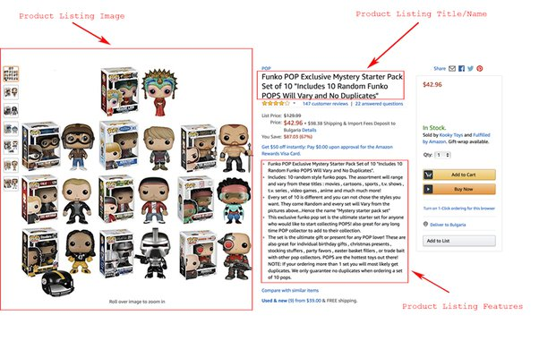**Case Study: Real-World Problems and Amazon's Innovative Solutions**

#### **Challenge 1: Efficient Delivery Logistics**

**Problem**: As Amazon's customer base grew, ensuring timely and efficient delivery of millions of packages daily became increasingly complex and challenging.

**Solution**: Amazon implemented a sophisticated logistics network, including the use of advanced algorithms and machine learning to optimise delivery routes. They also introduced Prime Air, a drone delivery system aimed at reducing delivery times to 30 minutes or less for certain products. Additionally, Amazon invested in their own fleet of aeroplanes and delivery vans to reduce dependency on third-party carriers and ensure more control over the delivery process.

#### **Challenge 2: Managing Inventory and Stock Levels**

**Problem**: Keeping track of inventory across numerous warehouses and ensuring stock availability without overstocking presented a significant logistical challenge.

**Solution**: Amazon developed an advanced inventory management system using artificial intelligence and real-time data analytics. This system forecasts demand with high accuracy, automated stock replenishment, and optimises warehouse storage space. Their use of robotics in warehouses, such as the Kiva robots, further streamlined inventory management by automating the movement and organisation of products within the warehouse.

#### **Challenge 3: Enhancing Customer Experience**

**Problem**: Maintaining a high level of customer satisfaction with an ever-growing customer base and diverse product offerings was challenging.

**Solution**: Amazon introduced various features to enhance the customer experience, such as one-click ordering, personalised recommendations powered by machine learning, and an easy-to-navigate user interface. The introduction of Amazon Prime provided customers with benefits like free two-day shipping, access to streaming services, and exclusive deals, significantly boosting customer loyalty and satisfaction.

#### **Challenge 4: Data Security and Privacy**

**Problem**: Protecting the vast amounts of customer data collected from various services and ensuring privacy became increasingly critical.

**Solution**: Amazon invested heavily in cyber security measures, implementing end-to-end encryption, multi-factor authentication, and regular security audits. AWS, Amazon's cloud computing service, offers robust security features and compliance certifications, ensuring that both Amazon and its customers' data are protected against cyber threats.

#### **Challenge 5: Reducing Environmental Impact**

**Problem**: With the environmental impact of packaging and logistics becoming a growing concern, Amazon faced pressure to adopt more sustainable practices.

**Solution**: Amazon launched initiatives such as the "Shipment Zero" project, aiming to make all shipments net-zero carbon, with 50% of all shipments net-zero by 2030. They also introduced the Frustration-Free Packaging program, which uses 100% recyclable packaging and reduces waste. Furthermore, Amazon has invested in renewable energy projects and committed to powering their operations with 100% renewable energy by 2025.

#### 

#### **Challenge 6: Expanding to Global Markets**

**Problem**: Expanding Amazon's presence in diverse global markets with different languages, cultures, and regulatory environments posed significant challenges.

**Solution**: Amazon adopted a localised approach, tailoring its website, customer service, and product offerings to meet the specific needs of each market. They established local fulfilment centres and partnered with regional delivery services to ensure efficient logistics. Additionally, Amazon invested in translating its content into multiple languages and complying with local regulations to facilitate smooth operations in international markets.

**Conclusion:**

By addressing these challenges with innovative solutions, Amazon has been able to maintain its position as a leading global e-commerce and technology company, continuously improving its operations and customer experience.

### **Top Features of Amazon:**

**1. Wide Product Selection**: Amazon provides a vast array of products across numerous categories, ranging from electronics and books to household essentials and groceries.

**2. Amazon Prime**: This subscription service offers benefits such as free two-day shipping on eligible items, streaming of movies and TV shows, ad-free music streaming, and exclusive deals on Amazon Prime Day.

**3. Customer Reviews and Ratings**: Amazon's robust review system allows customers to provide feedback on products, helping others make informed purchasing decisions.

**4. Amazon Marketplace**: Third-party sellers can list their products on Amazon, expanding the selection available to customers and fostering competition.

**5. Amazon Web Services (AWS)**: AWS provides cloud computing services to businesses and individuals, offering scalable solutions for computing power, storage, and database needs.

**6. Subscribe & Save**: This feature allows customers to schedule regular deliveries of products they use frequently, offering discounts and convenience.

**7. Amazon Echo and Alexa**: Amazon's smart home devices enable voice-controlled access to information, entertainment, smart home control, and shopping through Alexa, Amazon's virtual assistant.

**8. Amazon Fresh and Whole Foods Market**: Amazon Fresh offers grocery delivery and pickup services, while Whole Foods Market, acquired by Amazon, provides high-quality organic and natural products.

**9. Amazon Prime Video**: Subscribers have access to a wide range of movies, TV shows, and original content through Amazon Prime Video, available for streaming or download.

### **Schema Description:**

A schema description typically refers to a structured representation of data elements and their relationships within a database or a data format.

For Amazon, a schema description might involve outlining how product information is organised and stored in their database or how data is structured for their e-commerce platform. Here’s a basic schema description for Amazon's product catalogue:

**Product Entity:**

* **product_id**: Unique identifier for each product (primary key).
* **product_name**: Name of the product.
* **description**: Detailed description of the product.
* **category_id**: Identifier linking to the category table (foreign key).
* **price**: Price of the product.
* **stock_quantity**: Current available stock quantity.
* **brand**: Brand or manufacturer of the product.
* **ratings**: Average customer rating for the product.
* **reviews_count**: Number of customer reviews.
* **created_at**: Date and time when the product was added to the catalogue.
* **updated_at**: Date and time of the last update to the product information.

**Category Entity:**

* **category_id**: Unique identifier for each category (primary key).
* **category_name**: Name of the category (e.g., Electronics, Books, Home & Kitchen).
* **parent_category_id**: Identifier linking to the parent category (if applicable).

**Cart Entity:**

* **cart_id:** Unique identifier for each cart (primary key).
* **customer_id:** Identifier linking to the customer who owns the cart (foreign key).
* **product_id:** Identifier linking to the product added to the cart (foreign key).
* **quantity:** Quantity of the product added to the cart.
* **added_at:** Date and time when the product was added to the cart.

**Customer Reviews Entity:**

* **review_id**: Unique identifier for each review(primary key).
* **product_id**: Identifier linking to the product reviewed(foreign key).
* **customer_id**: Identifier linking to the customer who wrote the review(foreign key).
* **rating**: Numeric rating given by the customer (e.g., 1-5 stars).
* **review_text**: Text of the customer review.
* **review_date**: Date when the review was posted.

**Orders Entity:**

* **order_id**: Unique identifier for each order(primary key).
* **customer_id**: Identifier linking to the customer who placed the order (foreign key).
* **order_date**: Date and time when the order was placed.
* **total_amount**: Total amount charged for the order.
* **shipping_address**: Address where the order will be shipped.
* **status**: Current status of the order (e.g., processing, shipped, delivered).

**Customer Entity:**

* **customer_id:** Unique identifier for each customer (primary key).
* **name:** Name of the customer.
* **email:** Email address of the customer (used as a login username).
* **password:** Encrypted password for customer authentication.
* **phone_number:** Phone number of the customer.
* **address:** Complete mailing address of the customer**.**
* **city:** City of residence for the customer.
* **state:** State or province of residence.
* **country:** Country of residence.
* **postal_code:** Postal or ZIP code of the customer's address.

**Payment Entity:**

* **payment_id:** Unique identifier for each payment transaction (primary key).
* **customer_id:** Identifier linking to the customer making the payment (foreign key).
* **order_id:** Identifier linking to the order for which the payment is made (foreign key).
* **payment_method:** Method used for payment (e.g., credit card, debit card, PayPal).
* **amount:** Amount paid for the order.
* **payment_date:** Date and time when the payment transaction occurred.
* **payment_status:** Status of the payment transaction (e.g., pending, completed, failed).
* **transaction_id:** Unique identifier provided by the payment processor for the transaction.

**Relationships are:**

* **Category groups products:**Each product is associated with a category through ‘category_id’.This forms a many-to-one relationship where many products can belong to one category.
* **Customer saves addresses:**Customers place orders, linked through ‘customer_id’. This forms a one-to-many relationship where one customer can place many orders with different addresses.
* **Products are added in carts:**Products can be added to a cart, linked through ‘product_id’. This forms a many-to-many relationship where many products can be added to many carts.
* **Orders are made from cart:**Each order has been placed from the cart,linked through ‘product_id’.
* **Payments are made for orders:**Payments are linked to specific orders through order_id. This forms a one-to-one relationship where one payment is associated with one order.
* **Customer Reviews:**Customers write reviews, linked through ‘customer_id’. This forms a one-to-many relationship where one customer can write many reviews.

**ER Diagram:**

Let’s construct an Entity-Relationship (ER) diagram for the entities mentioned (Product, Orders, Customer Reviews, Payment, Category, Cart, Customer) which would involve visually representing their relationships and attributes. Below is a simplified ER diagram for these entities:

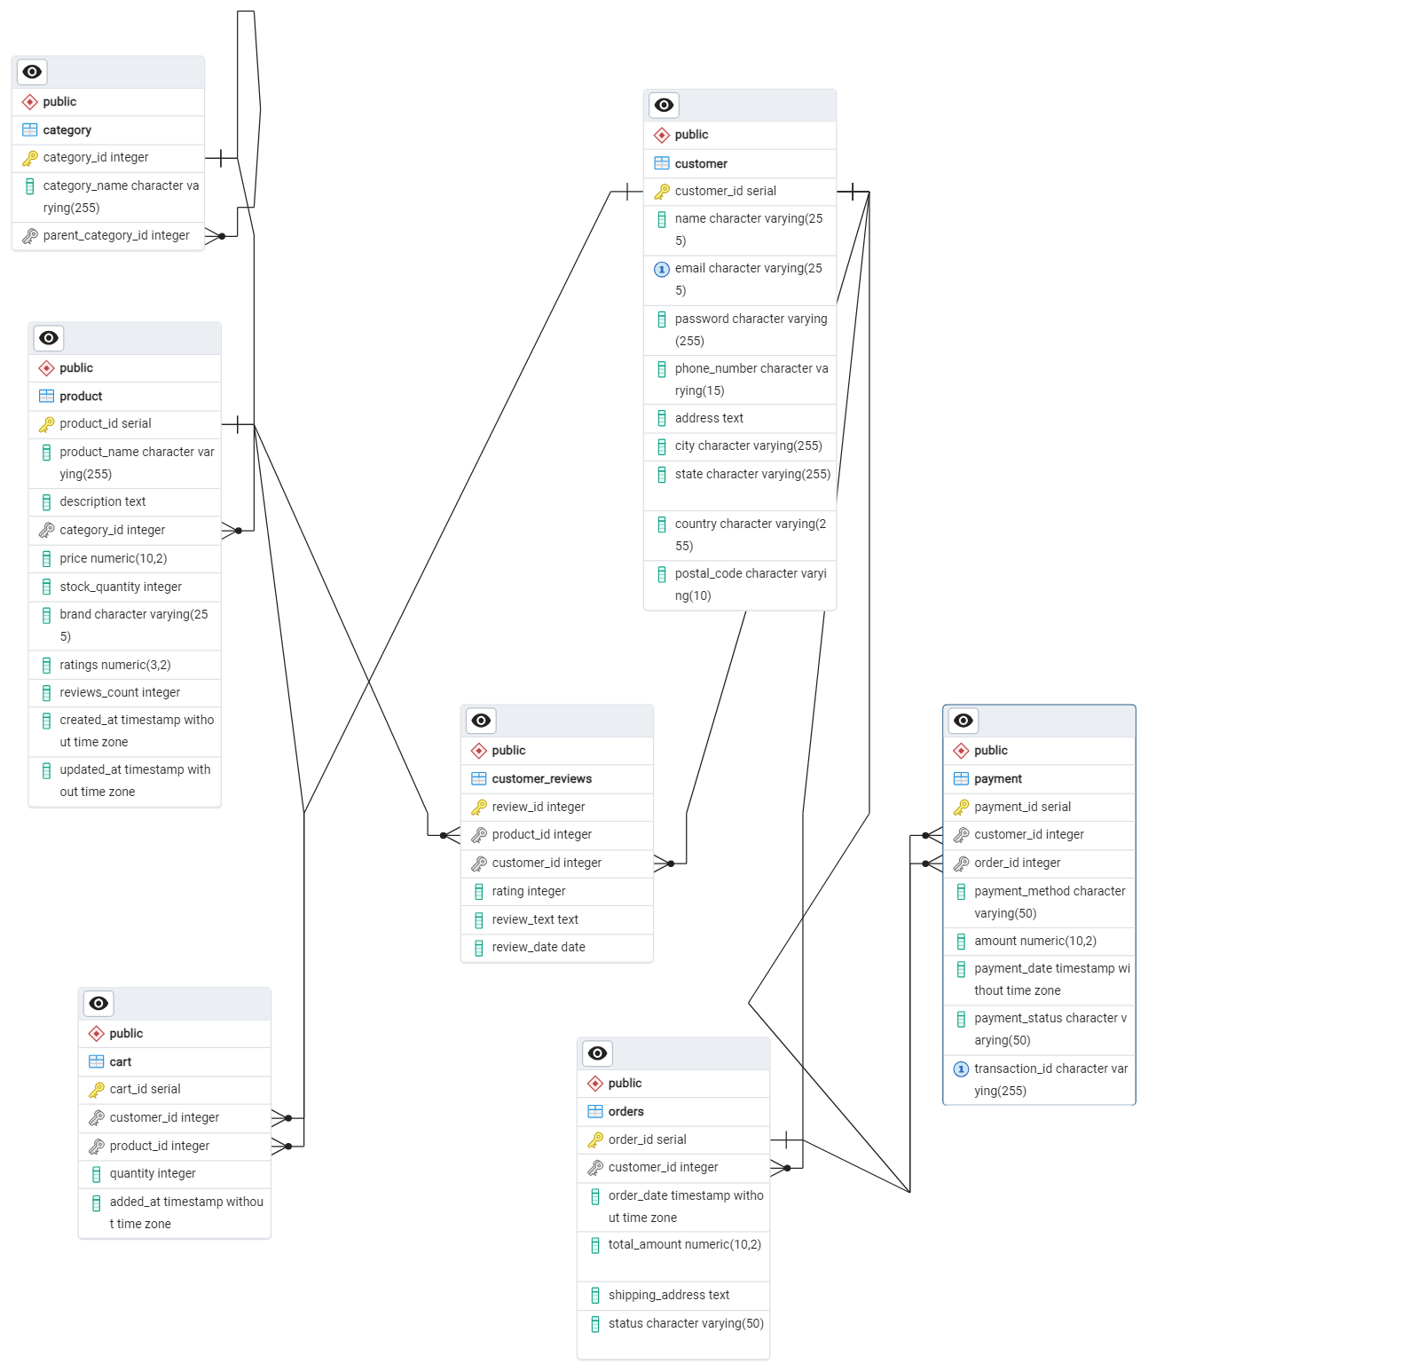

Conclusion:

In this case study, the well-organised database schema and detailed ERD (Entity-Relationship Diagram) show Amazon's careful planning in designing their database. This ensures data is managed efficiently and accurately. Key parts of the database, like Product, Orders, Customer Reviews, Payment, Category, Cart, and Customer, are all connected. This setup reduces duplicate data and makes retrieving information faster. This thorough design helps Amazon run a smooth e-commerce platform, allowing easy transactions, personalised shopping experiences, and the ability to grow. All of this contributes to Amazon's success and leadership in the market.

## 

# 